

Sound is produced by the interference of the flow of air through the mouth (and nose). Consonants are created when that airflow is directly restricted, or obstructed, so that air cannot escape without creating friction that can be heard.
The speech sound being obstructed can be voiced or unvoiced. It can be obstructed in a number of different places in the vocal tract. The nature of the obstruction can take a number of forms, or manners.
Defining characteristics of consonants include:
- Voiced or Voiceless
- Place of articulation
- Manner of articulation

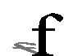



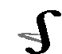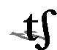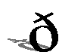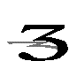

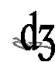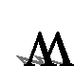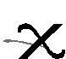

as in red, road, wrong, read.
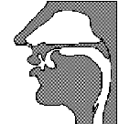

Possible positioning
- word initial as in rope, real, rob
- word medial as in mirror, very, arrow
- word final as in far, poor, here but only when the next sound is a vowel.
/r/ is a very tricky consonant. The tongue-tip is fairly close to the back of the alveolar ridge with the sides of the tongue in contact with the sides of the palate.
In British English, /r/ is not pronounced when it comes before a consonant (even if it is written). The same is true if /r/ comes at the end of a word. So, it is only pronounced if the following word begins with a vowel.

Voice =

Place =

Manner =

as in think, thigh, thought, thank.
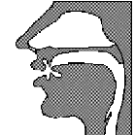

Possible positioning
- word initial as in think, thirst, thin
- word medial as in ether, lethal, author
- word final as in heath, path, cloth
When articulating this sound, you cannot feel any vibration of the throat indicating that it is a voiceless sound. You can feel air being forced between the tip of your tongue and your upper front teeth. Any sound articulated at the teeth is a dental sound, whereas any sound that is created by creating friction by forcing air through a narrow channel is known as a fricative. The symbol for this sound comes from the Greek symbol theta. The spelling system of English does not distinguish between this sound and the harder /th/ sound used in /that/.

Voice =

Place =

Manner =

as in ship, shape, sheep, shop.
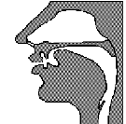

Possible positioning
- word initial as in shop, sheep, shirt
- word medial as in fissure, mission, bishop
- word final as in wish, cash, finish
This sound clearly carries no voice. However, it is quite difficult to differentiate where in the mouth it is articulated. It seems to be between the alveolar ridge and the hard-palate and so some people call it a palato-alveolar. As the sound is being forced between the tongue and the palato-alveolar, it is a fricative.

Voice =

Place =

Manner =

as in yet, yacht, yellow, yankee, few.
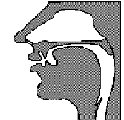

Possible positioning
- word initial as in year, young, you
- word medial as in lawyer, beauty, value
This may look like a /j/ sound, but it is the phonetic representation of the /y/ sound. It is a semi-vowel, having some of the qualities of a vowel and of a consonant.

Voice =

Place =

Manner =

as in cheap, chair, Charles, change.
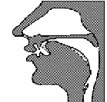

Possible positioning
- word initial as in cheese, cheap, charm
- word medial (intervocalic) as in richer, nature, feature
- word medial (consonant preceding) as in mischief, juncture, capture
- word final (intervocalic) as in catch, much, coach
- word final (consonant preceding) as in bench, branch, inch
If you place your hand on your throat you can clearly feel that this sound carries no voice. Also, the fact that it is a fricative means that the tongue is spread over the hard palate and the alveolar ridge making it a palato-alveloar sound.

Voice =

Place =

Manner =

as in the, this, that, thy.

Possible positioning
- word initial as in though, there, they
- word medial as in within, leather, father
- word final as in with, soothe, seethe
If you feel your throat, you should be able to detect the vibrations of a voiced consonant. You can also feel your tongue tip acting against your upper front teeth. The fact that air is forced between the tongue and the teeth means that it is a fricative consonant.
In normal English spelling, no distinction is made between this and the softer /th/ sound used in /think/.

Voice =

Place =

Manner =
as in treasure, vision, garage, closure.

Possible positioning
- word initial (in French loan words) as in gigolo, genre
- word medial measure, usual, confusion
- word final (in French loan words) as in prestige, rouge, beige
Placing your finger over your throat, you can clearly feel the vibration of voice. The position of the tongue is somewhere around where the hard palate and the alveolor ridge meet, making it a palato-alveolar consonant. You should also be able to feel the air being forced between the tongue and the palato-alveolar ridge, making it a fricative.
This sound is usually found in the middle of English words, but is also often heard at the beginning of foreign loan words found in English (e.g. gendarme, Jean Paul).

Voice =

Place =

Manner =

as in hang, song, thing, king, sting.
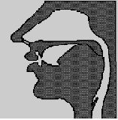

Possible positioning
- This sound does not appear in word initial positions in R.P.
- word medial as in singer, longing, hanger
- word final as in bang, wrong, tongue
This sound is never found at the beginning of a word. It is a voiced sound made by the back of the tongue stopping against the soft palate. If you place your finger in front of your nose, you should be able to feel the expulsion of air through your nose, which makes it a nasal consonant.

Voice =

Place =

Manner =
as in jeep, gesture, joust, jump.

Possible positioning
- word initial as in jest, jar, jerk
- word medial (intervocalic) as in midget, fragile, urgent
- word medial (consonant preceding) as in danger, soldier, object
- word final (intervocalic) as in ridge, large, age
- word final (consonant preceding) as in change, sponge, hinge
This sound is the voiced equivalent of the /tʃ/sound. The fact that it is a fricative means that the tongue is spread over the hard palate and the alveolar ridge making it a palato-alveloar sound.

Voice =

Place =

Manner =

as in bu'er for butter, wa'er for water, mar'in for Martin.
A glottal stop is when there is a complete obstruction to the passage of air resulting in a period of silence. It is becoming more common in many non-RP accents in Britain. However, pronouncing words as such is not desirable.



Vowels differ from consonants in that there is no noticable obstruction in the vocal tract during their production. Air escapes in a relatively unimpeded way through the mouth and/or nose.

If you try saying aaaaa, iiiii, uuuuu, eeeeee, oooooo to yourself you should be able to feel that, although your tongue moves about your mouth, it never actually obstructs the airflow. You should also be able to feel that the position of the tongue changes for each of those vowels.

Vowels are determined by changes in position of the lips, tongue and palate. These changes can be very slight and difficult to detect. The vowel chart on the following page attempts to map the positions of the tongue and jaw in articulating vowels. It is worth mentioning that, as it is so difficult to determine the exact position of the lips, tongue and palate, there is no single agreed upon vowel chart.

In English, vowels can also glide into one another to form diphthongs and even triphthongs.

Vowels are far more difficult to transcribe than consonants and are also an extremely important area of English phonology as they make up the greatest difference between English varieties.

Vowel Chart

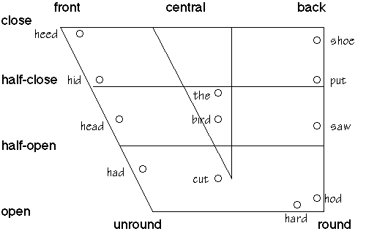
The vowel chart is quite a complicated looking diagram. All that it is trying to do is to represent where the tongue lies in relation to the openness of the mouth when you sound a vowel. So the front closed vowel /i:/ means that your tongue is in a forward position in the mouth which is in a relatively closed position. Try saying it to yourself and then contrast it with the open back sound in the diagram.

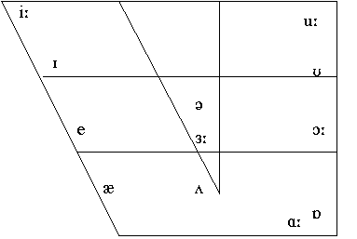

Short Vowels
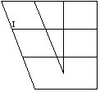

as in wit, mystic, thick, finish.

Spelt as
- /i/ in fifth, rich, with, sit (61%)
- /y/ in city, rhythm, symbol (21%)
- /e/ in wicket, pretty, wicked (16%)
- /ie/ in ladies, sieve
- /a/ in village, private
- /o/ in women
- /u/ in busy
- /ay/ in monday, sunday
- /ai/ in fountain

When you say this vowel sound, the front of the tongue is raised towards the palate. In fact, the position of the whole tongue is relatively high in the mouth, making it a closed vowel. The lips are slightly spread.

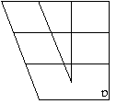

as in cot, what, cost, mop.

Can occur as
- /o/ in sorry
- /au/ in because
- /a/ in what
- /ou/ in cough
- /ow/ in knowledge

The tongue and jaw are lowered as the back of the tongue is used to articulate this vowel. Hence it is a back, open (low) vowel. The lips are slightly rounded.
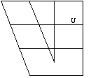
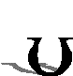
as in book, wood, could, put.

Can occur as
- /o/ in woman
- /oo/ in good
- /u/ in full
- /ou/ in could

The tongue and jaw are raised as the back of the tongue is used to articulate this vowel. Hence it is a back, close (high) vowel. The lips are rounded.

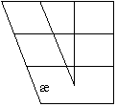

as in hat, man, cash, cap.

In conventional spelling, this sound is spelt with an 'a' 99% of the time. Alternatively, it can be spelt with an 'ai' as in plait or plaid.

This vowel is a front vowel since the front part of the tongue is raised when it is articulated. It is also an open (low) vowel. This means that the tongue is in a low position with the jaw also being lowered. The lips are slightly spread.

This traditionally short vowel has become slightly longer than the other short vowels. This lengthening is apparent before voiced consonants such as in cab, bad, badge and man.

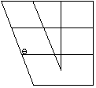

as in fell, set, many, meant.

Can occur as
- /e/ in egg
- /a/ in any
- /eo/ leopard
- /ea/ in realm
- /ei/ in leisure

The front of the tongue is used in the production of this vowel, making it a front vowel. It is also a close/middle vowel in that the position of the tongue and jaw is slightly raised. The lips are slightly spread.

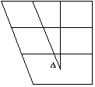
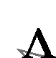
as in cut, bus, come, rough.

Can occur as
- /o/ in come
- /oo/ in flood
- /u/ in sun
- /ou/ in trough
- /oe/ in does

This is a central vowel, and one which is more open than mid-ranged. The lip position is a neutral one.

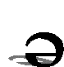
as in another, brother, the, postman.

The schwa is an unstressed central vowel and is the most common vowel to appear in English. It is one of the problems of English teaching that the most common vowel has no regular character to represent it; learners of English can have a very difficult time with weak vowels.



Weak forms are those words that are pronounced in an unstressed manner. Many of the most common words in English can come in either a strong or a weak form. They are nearly all function words such as conjunctions, articles, pronouns, prepositions and some auxiliary and modal verbs.

Generally the strong forms of these words are used when they are being directly quoted, when they are being contrasted or if they appear at the end of a sentence.

The pronunciation of a weak form can be so different from the strong form that it is barely recognizable as being the same word. If said in isolation, it would be all but unintelligible. Usually, it is the context that makes it understandable.

It is possible to use only strong forms in English, and some non-native speakers do exactly this. However, it sounds very unnatural to a native speaker and it will also mean that a person who only uses the strong form of English will have trouble understanding native speakers of English who use the weak form all of the time.

Weak form examples
The most common weak form examples are introduced as follows:

Articles
The
    - before consonants
      - The man did it.
    - before vowels
      - The orange.
A, An
    - before consonants
      - Ride a bike
    - before vowels
      - Pick an apple.

Conjunctions
And
      - Come and see.
      - Fish and chips
But
      - It's cheap but reliable.
      - Fish and chips
Than
      - better than expected

Pronouns
His
    - When it occurs before a noun
      - Take his coat
Her
    - before consonants
      - Take her home.
    - before vowels
      - Take her out.

Long Vowels
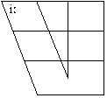


as in beat, receive, see, unique.

Possible occurences
- /ee/ in see
- /ea/ in eat
- /ie/ in yield
- /ei/ in seize
- /e/ in scene
- /i/ in police
- /eo/ in people
- /ey/ in key
- /ay/ in quay

Being a long vowel, it almost sounds like a diphthong in RP. It is long enough to be one, but it does not actually glide into another vowel sound. The lips are only slightly spread.

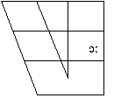

as in caught, port, talk, thought.

Can occur as /aw/ in law /ou/ in bought /au/ in taught /a/ in all /or/ in horse /oor/ in door /oar/ in hoarse /our/ on pour /oa/ in broad


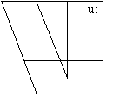
as in spoon, you, blue, balloon.

Can occur as
- /o/ in who
- /oo/ in fool
- /u/ in rude
- /ou/ in soup
- /ew/ in few
- /ue/ in blue
- /eu/ in feudal
- /oe/ in shoe
- /ui/ in fruit

This vowel is towards the back and is a close sound. The lips are only moderately rounded.

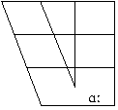

as in cart, half, pass, laugh.

Can occur as
- /a/ in pass
- /ar/ in art
- /au/ in aunt
- /er/ in clerk
- /ear/ in hearth
- /al/ in calm

This is an open vowel, tending towards, but not completely in, the back position. The lip position is neutral.

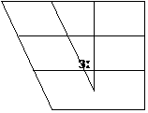
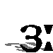
as in hurt, bird, hearse, word.

Can occur as
- w + /or/ as in word
- /our/ in scourge
- /ir/ in bird
- /yr/ in myrtle
- /er/ in serve
- /ur/ in fur
- /ear/ in earth

This is a central vowel. It is commonly used by English speakers as a hesitation sound (spelt 'er'). The lip position is neutral.

Diphthongs are those sounds that consist of a movement or glide from one vowel to another. The first part of a diphthong is always longer and stronger than the second part; as the sound glides into the second part of the diphthong the loudness of the sound decreases.

One of the most frequent errors made by language learners is to use pure vowels instead of diphthongs.


as in late, day, vein, fail.

This diphthong begins with the same /e/ as in 'get' and 'men'. The sound then glides from a relatively more open to a more closed vowel position.


as in buy, fine, sight, file.

This diphthong begins with an open vowel which is between the front and back position. It is quite similar to the vowel sound found in 'cut' and 'sun'.


as in boy, join, voice, foil.

The first part of this diphthong is the vowel sound found in 'caught' and 'born' before gliding to the front, close position.
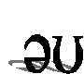
as in slow, go, dough, coat.

This diphthong starts in the central schwa position. The sound then glides to the back, close position of the vowel sound found in 'put' and 'pull'.


as in now, drought, fowl, cow.

This diphthong starts in a slightly more front position of the vowel found in 'far' and 'car'. A glide to the vowel sound in 'put' would be too large a movement, so the glide is not fully completed.


as in sheer, fear, idea, mere.

This diphthong starts a little bit closer than the vowel in 'bit' and 'bin'. It then glides into the central schwa position.


as in share, care, fair, bear.

This vowel starts with the vowel found in 'get' and 'beg' before gliding to the central schwa position.


as in sure, endure, lure, pure

This diphthong starts in a slightly closer position than the vowel in 'put' and 'push' before gliding towards the central schwa position.



Triphthongs are those sounds that consist of a movement or glide from one vowel to another and then onto a third. They are very similar to diphthongs, but have an extra schwa on the end of the diphthongs. There are said to be only five triphthongs, but there are a number of occasions when diphthongs meet other vowels over word edge boundaries.
The five clear examples of triphthongs are as follows:

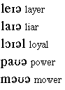

Stress and Intonation

Both stress and intonation clearly influence the manner and meaning of what we say and yet they do not alter the individual phonemes or sounds. The way we transcribe the phonemes is unchanged by stress or intonation. However, stress and intonation clearly have a role in the way in which we speak and it has to be taken into consideration. Therefore, the following sections detail what that role is and how we go about representing them in phonological transcriptions.
Intonation
Stress

The messages that we convey to one another depends just as much on how we say something as on what it is that we actually say. Most of the information you have been given up to now deals with the mechanics of articulating sounds. However, it is possible to use the same words to convey a huge variety of meanings, moods or intentions. The way we do this is by using intonation.

In the study of intonation, pitch, loudness and length are the most important factors. They work together to give certain syllables prominence over the others. The concepts of intonation are very closely related to those in stress, the difference being that stress is concerned with individual words, whereas intonation extends over a phrase or utterance.

There are five clearly discernable intonation patterns that are used on a regular basis in English.
- Falling
- Rising
- Flat
- Fall-Rise
- Rise-Fall



(prominence)

Stress is a term that we apply to words in isolation which have more than one syllable. It refers to the property that certain syllables carry which make them stand out from the rest of the word. It seems certain that stressed syllables are made with more effort than unstressed ones; the muscles in the lungs seem to expel air more aggressively than for unstressed syllables.
The prominence that these syllables exhibit are usually pronounced in four ways.
- Pitch
- Length
- Loudness
- Quality
Any of these four factors can occur alone or in combination to produce the prominence that marks a stressed syllable from an unstressed one.
The notation of stress is the high mark demonstrated in the following examples:

for stress on the first syllable.

for stress on the second syllable.

for stress on the third syllable.

You just have to look at how stress is notated. We shall return to the question of where to place stress shortly. In some, usually longer words, it is possible to pick out a second, weaker, stressed syllable from the primary stress. This is known as secondary stress and it is notated with the low mark

eg:
In this example, the third syllable is more pronounced than the first syllable, but the first syllable is still more prominent than the other syllables and so carries the low mark.

- Pitch
Pitch is an auditory sensation that places sounds on a scale from high to low. Every syllable has pitch, however, any syllable that is articulated with a noticeably different pitch will be deemed to carry stress. This can go either way: if all the syllables are said in a low pitch except one, then that higher pitch syllable will be deemed to carry the stress of the word. Pitch also plays a central role in intonation.

- Length
Length seems to play a role in stress. Generally, if one syllable has a longer length than the others in the word then it is deemed to be the one carrying stress. Length is one of the more important determiners of stress.

- Loudness
It seems obvious that if one syllable is articulated louder than the others then it will have achieved some prominence from the other syllables. This prominence would then make that syllable the stressed syllable. However, it is very difficult to make a sound louder without affecting the length, pitch or quality of that syllable. If you could only change the loudness of a sound then the perceptual change is not as great as you would expect.

- Quality
A syllable will carry prominence if it contains a vowel that is different in quality from the surrounding vowels. This effect is usually achieved by having a strong vowel in the midst of weak ones. The prominence of the strong vowel is contrasted with the weaker vowels.

How to determine where stress lies
English is not a language that follows precise rules for the placement of stress. In French, the last syllable is usually the stressed one; in Polish, it is usually the penultimate one; and in Czech, it is generally the first syllable that is stressed. Unfortunately, English has a very complex set of procedures that determine stress. It should be noted that nearly all English speakers agree on where stress should be placed in individual words so the English system of stress does have some method.

One syllable words
Obviously, these present no problems because, when pronounced in isolation, they receive the primary stress. (There is no other syllable competing with it.)

Two syllable words
The choice is still quite simple; either the first or the second syllable will be stressed.
It is usually the case with verbs that, if the second syllable of the verb contains a long vowel or diphthong, or if it ends with more than one consonant, then the second syllable is stressed.
If the final syllable contains a short vowel and one or no final consonant, then usually, the first syllable will be stressed.
- Two syllable adjectives are stressed in the same manner.
Nouns generally use a different rule. If the second syllable contains a short vowel, then the stress usually comes on the first syllable - otherwise it will be on the second syllable.

Three syllable and more words
Determining stress becomes very complicated from this point on. The rules start to become quite arbitrary with more exceptions than can easily be explained away. One general hint to remember is that weak syllables never carry stress. Therefore, any syllable with a schwa in it will never be the stressed syllable. Despite the large amount of research done on the subject of stress, it is still one area of which we have little understanding.

